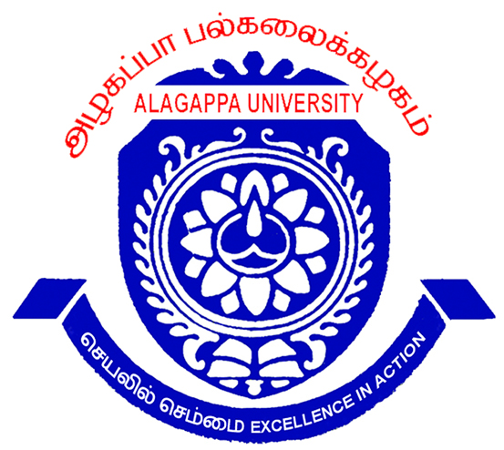
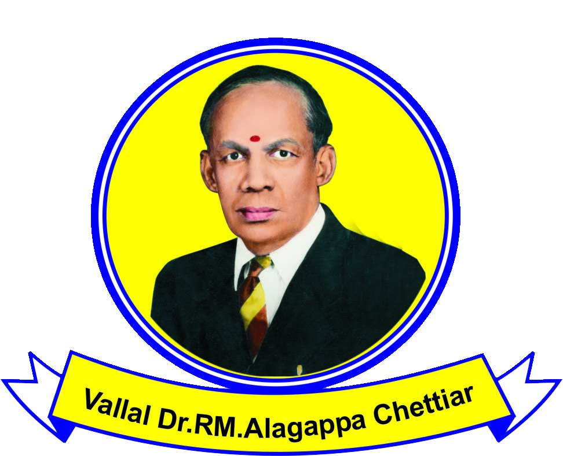
ALAGAPPA UNIVERSITY
KARAIKUDI - 630003

(A State University Re-accredited with “A” Grade by NAAC)

PROSPECTUS
Alagappa University, established by the Government of Tamil Nadu under an Act of the State Legislature in 1985, and located on a sprawling expanse of about 420 acres in the business town of Karaikudi in Sivaganga District in Tamilnadu is ideally suited for higher education. The campus is accessible from Tiruchirappalli and Madurai in about 2 hours by surface mode of transport.

This seat of Higher Education has emerged from the galaxy of institutions initially founded at Karaikudi by the munificent and multifaceted personality, Padma Bhushan Dr. RM. Alagappa Chettiar and is groomed to prominence as yet another academic constellation in Tamil Nadu. As a member of the Common wealth Universities and Association of Indian Universities, it has rewarding relations with other national and international academic/ research/ industrial institutions that promise a spectacular future to the learners. It has been recognised under Sec.2(f) and 12(b)of the UGC Act. It has been awarded coveted “A” Grade by NAAC in Reaccreditation.

Vision > Excellence in Action: The University’s motto is “Excellence in Action” and it is determined to keep before it the vision of excellence in all spheres of education. To achieve this, it is continually upgrading its programs of studies and research and is a fore-runner in introducing many frontier level programs of learning as well.
Motto | Excellence in Action
Vision | Excellence in all Spheres of Education, with particular emphasis on ‘PEARL’- Pedagogy, Extension, Administration, Research and Learning.
Mission | The University is committed to provide a High Quality Higher Education to the learners so that they are transformed into intellectually competent human resources that will help in the uplift of the nation to Educational, Social, Technological, Environmental and Economic Magnificence (ESTEEM).
Objectives | - Providing for Instructions and Training in such Branches of Learning as the University may determine.  ii. Fostering Research for the Advancement and Dissemination of Knowledge.
Quality Policy | Attaining Benchmark Quality in every domain of ‘PEARL’ to assure stakeholder Delight through Professionalism exhibited in terms of strong purpose, sincere efforts, steadfast direction and skill full execution.

15 Schools of Learning: The University has 15 Schools of Learning comprising, 23 Departments, 2 Constituent Colleges and 10 Centres of Development and Studies offering over 60 Programs at UG/ PG/ M.Phil / Ph.D levels. Besides, the University is offering about 65 programs under the Distance Education mode and another 40 skill-oriented programs through Collaborative mode. Further, 28 Arts and Science Colleges - Government, Government Aided and Self financing- have been affiliated to the Alagappa University.

Infrastructure: The University is having good educational infrastructure with state of art Science laboratories with modern advanced scientific equipment. All Schools have computer labs with net connectivity. There are Central and Departmental libraries with on-line surfing facility, besides latest volumes of books and journals. There are three modern Auditoria capable of accommodating gathering for international level colloquiums and conferences. There are as many as 5 large play grounds and as many small ones, enough even to host inter-university national level sport meets/tournaments.

ICT Orientation: The students must be savoir-faire in utilizing ICT resources. Every program has minimum 2 courses on computer education. There are also programs like MSc (Bio-informatics), MBA (International Business & E-Commerce), MBA (Systems –Optional), and so on with more ICT thrusts.

Human Resources: Close to 200 Faculty Members (Regular/DDE/Visiting faculty members) with rich Teaching & Research Skills, and Project & Consultancy acumen take care of academic/research works. The faculty members are very strong in publication in national and international journals, securing projects from government and business institutions, organizing national and international conferences and in collaborating with Indian and overseas research institutions. The Administration is learner friendly.
Pedagogy: Well aware of the fact that the ‘trained mind’ outsmarts the ‘theoretical mind’ in every facet, skill building in the learners is intertwined with imparting knowledge. Every program has Training component and/or Project work, besides practical courses, language lab courses, computer lab courses, etc. It is said, 90% of education is encouragement. That is given to everyone, through counseling and guidance.
Extension Activities: The multi-skill-set development of the learners and also the development of the neighborhood community are important in any scheme of education. The University takes care of this, through co-curricular courses. The Village Placement Program, NSS, YRC, RRC, etc are committed to these development domains. There are over 20 Cells/Clubs that provide opportunity for students to learn and also serve the society in many divergent ways. Service makes a perfect man.

Request for application: Application for admissions is invited from the intending learners. Applications can be obtained from the Registrar, Alagappa University, Karaikudi - 630 003 on payment of the cost of the application, as applicable, through a crossed Demand Draft drawn in favour of, ‘The Registrar, Alagappa University, payable at Karaikudi’ as follows:

i. All Entrance Programmes: Rs.500 | For SC/ST candidates Rs.250/ - on production of attested Community Certificate copy)
ii.All Non-Entrance Programmes: Rs.300 | For SC/ST candidates Rs.150/ - on production of attested Community Certificate copy)
Applications can be had in person or through post. For postal mode, the requisition letter and course of study with applicable demand draft must be accompanied.

Submission of Application: The candidates should submit the filled in application form to the Registrar, Alagappa University, Karaikudi during the office hours 10am -5.45 pm or by post before the stipulated date.

SELECTION BASIS

PROGRAMMES | BASIS OF SELECTION
i. B.Ed./ M.Ed. | Entrance Test marks with qualifying degree
ii.MBA  (all programmes/MCA) | Entrance Test and Group Discussion / Interview marks with qualifying degree
iii. M.Sc.Biotechnology | Entrance Test and Group Discussion / Interview marks with qualifying degree
iv. Post M.Sc ADMD | Entrance Test marks with qualifying degree
iii. B.P.Ed/D.P.Ed | Medical Test, Physical Efficiency Test & Games Test with qualifying degree
iv. M.P.Ed | Entrance Test, Medical Test, Physical Efficiency Test, Games Test & Interview with qualifying degree
FOR ALL OTHER PROGRAMMES SELECTION SHALL BE ON THE BASIS OF MARKS OBTAINED IN THE QUALIFYING DEGREE

The provisionally selected candidates will be intimated by post. Queries regarding the receipt of application in this office will not be entertained.

PROGRAMMES OFFERED | ELIGIBILITY CRITERIA
01 MBA (2 years)  02 MBA ( Banking & Insurance) (2 years)  03 MBA (Corporate Secretaryship) (2 years)  04 MBA (International Business) (2 years) | A Pass in any degree 10+2+3 pattern
05 MCA (Master of Computer Applications)  (3 years) | A first class Degree in Mathematics/BCA/Physics/Chemistry with ancillary Mathematics/Statistics/Computer Science/Applied Science/ B.Com /BBA/B.B.E OR Equivalent thereto in the related disciplines (for SC/ST candidates 55%)
06 M.Sc. Biotechnology (2 years) | Bachelor’s degree in Physical Sciences (Physics & Chemistry) Biological (Botany&Zoology)Biochemistry/Microbiology/Biotechnology,  Agricultural,Veterinary,FisheriesSciences,Pharmacy/Engineering/  Technology or equivalent degree with at least 55%marks.
07 Post M.Sc, (Advanced Diploma  Course in Molecular Diagnostics).  (One Year) | A first class M.Sc., Degree in Life Sciences (Biotechnology, Botany, Zoology, Biochemistry, Microbiology OR Genomic sciences), Agriculture/Veterinary Sciences/Fisheries Sciences, Pharmacy or M.Tech. in Biotechnology/Life Sciences or equivalent (Minimum marks for SC/ST candidates is 50%. Studentship Rs.5,000/- per month given.
08 M.Ed. (One Year) | B.Ed., with 55% for OC and 50% for BC/MBC/SC/ST, in aggregate. Those who have completed the B.Ed., course can also apply.
09 B.Ed.  Tamil / English / Mathematics /Physical Sciences / Biological Sciences /History & Commerce (One year) | A degree in Tamil / English / Mathematics/ Physics/Chemistry/Botany/Zoology/History/with these marks: for  OC-55%,BC-45%,MBC-43%,SC&ST-40% in Part III and allied Subject: For Commerce M.Com. alone is eligible.
10 M.P.Ed., (2 Years) | B.P.Ed. Degree.
11 B.P.Ed. (One Year) | BPE course or its equivalent of three years duration or Graduate who has secured First , Second & Third position in Inter-Inter-Collegiate sports/games tournaments possessing NCC “C” certificate or passed basic course in Adventure course or graduate with one year Training program in Sports Science, Sports Management, Sports Coaching, Yoga Olympic Education & Sports Journalism etc.
12 D.P.Ed., (2 Years) | The candidates possessing the Higher Secondary qualification of with 45% marks are eligible. For those who have participated in State and National level Sports events, the minimum percentage of marks in +2 should be 40% Age 17-25 years OC/BC/MBC 17-30 years for SC/ST/ Widow/ Orphan / Deserted Women.
13 B.Ed. Special Education  Tamil / English / Mathematics /Physical Sciences / Biological Sciences /History & Commerce  (One year) | A degree in Tamil / English / Mathematics/ Physics/Chemistry/Botany/Zoology/History/with these marks: for  OC-55%,BC-45%,MBC-43%,SC&ST-40% in Part III and allied Subject: For Commerce M.Com. alone is eligible.
14 M.Sc. Mathematics (2 years) | B.Sc., Mathematics/Applied Mathematics/Special Mathematics.
15. M.Sc.(Computer Science) (2 years) | Degree in BCA/B.Sc. Computer Science/equivalent thereto in the related disciplines with50 % marks
16 MCA (Master of Computer Applications)  (WEEK-END) (3 years) | A first class Degree in Mathematics/BCA/Physics/Chemistry with ancillary Mathematics/ Statistics/ Computer Science/Applied Science/ B.Com /BBA /B.B.E .Equivalent thereto in the related disciplines (for SC/ST candidates 50%)
17 M.Sc. Physics (2 years) | B.Sc., Physics, Applied Science, Special Physics/Electronics Minimum of 55% in Part III/for SC/ST candidates 45%
18 M.Sc. Chemistry (2 years) | B.Sc., Degree Examinations with Chemistry/Special Chemistry/Industrial Chemistry/Textile Chemistry/Electro Chemistry/Applied Chemistry/and any other specialization in Chemistry as main subject of study and any two of Maths, Physics, Botany, Zoology, Computer Applications, Microbiology, Textile Chemistry. Electro Chemistry Applied Chemistry as ancillary subjects with a minimum of 55% in Part III, (for SC/ST candidates 45%)
19 M.Sc.Chemistry(Specialization in Textile)
(2 years)
20 M.Sc.Chemistry(Specialization in Electro)
(2 years)
21 M.Sc. Energy Science (2 years) | B.Sc., Physics, Energy Science, Applied Physics, Electronics, Nuclear Physics, Bio Physics, Nanoscience, B.Sc., Chemistry or B.Sc., Botany or B.Sc., Zoology with Mathematics at +2 level. Minimum of 55% in part-III (for SC/ST candidates 45%)
22 M.Sc. Marine Biology  (2 years) | B.Sc., in Zoology/Botany/Chemistry/Fishery Science/Earth Science/Physics/Agriculture/Microbiology/Applied sciences or equivalent thereof in the related disciplines at least 50% marks for SC/ST 45% marks
23 M.Sc. Bioinformatics (2 years) | Bachelor’s Degree in Biological Sciences (Botany, Zoology, Bio-chemistry, Microbiology, Biotechnology, Bioinformatics agricultural/Veterinary/FisheriesSciences/Pharmacy/Engineering/Technology or equivalent Degree with at least 50% of marks in major and allied subject both in theory & Practical) in all 3 years.
24 M.Sc.Nanoscience and Technology  (2 years) | B.Sc.(Maths), Physics, Biology as main subject or B.Sc., Applied Maths, Applied Physics Electronics, Nuclear Physics, Bio-Physics, Industrial Chemistry, Polymer Chemistry, Applied Chemistry, Pharmaceutical Chemistry, Biotechnology, Nano biotechnology, Biochemistry and Micro biology or any other Specialization in Mathematics/Physics, Chemistry and Biology.
25 M.Sc. Animal Health & Management  (2 years) | Bachelor’s Degree in Biological Sciences.(Zoology, Animal Science, Biochemistry, Microbiology, Biotechnology, Bioinformatics, Veterinary Science, Fisheries Science, Pharmacy or equivalent degree) with atleast 50% of marks.
26 M.Sc Zoology (2 years) | Bachelor’s Degree in Biological Sciences, (Zoology, Biochemistry, Microbiology, Biotechnology, Bioinformatics, Veterinary Science, and Fisheries Science, Pharmacy or equivalent degree) with at least 50% marks.
27 M.Sc. Bio-electronics & Biosensors  (2 years) | B.Sc., Chemistry, Physics, Biology, Biotechnology, Zoology, Botany, B.E., Chemical Engineering, Electronics and Communications with aggregate 55% or GPA 7.0
28 M.Com (2 years) | B.Com/BBM/BBA/ B.A Corporate Secretaryship, B.A Economics with accountancy as Ancillary
29 M.A. Tamil (2 years) | B.A/B.Lit Degree with Tamil B.A., B.Sc., under Part I or Part III
30 M.A. English (2 years) | B.A., English Literature/B.A/ or B.Sc. with part I – II English.
31 M.A. Gender Studies (2 years) | Degree in any discipline; both genders can apply.
32 MSW (Master of Social Work) (2 years) | Degree in any discipline; both genders can apply
33 M.A. Rural Development (2 years) | Degree in any discipline
34 M.A. Economics (2 years) | B.A. in Economics / Business Economics / Cooperation / B.B.M. /B.B.E./ B.B.A./ B.Com./ B.Sc. Statistics and B.Sc. Mathematics.
35 M.L.I.Sc (2 Years) | Any Degree
36. PG Diploma in Yoga Education  (One Year) | Any Degree (Part-Time)
37 Certificate in Cuisine and Hospitality (6 Months) | HSC Pass
38 Certificate in Tourist Guideship and Hospitality  (6 Months) | HSC Pass
39 Diploma in Tourism and Hospitality  (One year) | HSC Pass
40 Diploma in Cuisine and Hospitality (One Year) | HSC Pass
41 Cert. in Guidance & Counseling (6 months) | HSC Pass
42 Cert. in Non-Governmental Organisation  Management (6 months) | HSC Pass
43 Certificate in Beauty Therapy (6 months) | SSLC Pass (Both Full Time/Part Time)
44 Diploma in Beauty Therapy (One year) | HSC Pass (Both Full Time/Part Time)

FEES PAYABLE PER ANNUM
S.No | PROGRAMMES | Tuition fee including Guest Lecture fee RS. | Computer LAB FEE RS | SPL FEE RS. | Other fees Rs. | Special Lecture & Industrial Visit /Camp Rs. | First year Total fee Rs. | Second year Total fee Rs. | Third year  Total fee Rs.
01. | MBA | 12000 | 2000 | 2000 | 1000 | 3000 | 20000 | 19000
02. | MBA (B&I) | 8000 | 1000 | 2000 | 1000 | 1000 | 13000 | 12000
03. | MBA (Corp. Secretaryship) | 8000 | 1000 | 2000 | 1000 | 1000 | 13000 | 12000
04. | MBA (IB & E&C) | 8000 | 1000 | 2000 | 1000 | 1000 | 13000 | 12000
05. | M.Com | 1500 | 500 | 2000 | 1000 | -- | 5000 | 4000
06. | MCA | 3000 | 4000 | 2000 | 1000 | -- | 10000 | 9000 | 9000
07. | MCA (Week End Program) | 3500 | 4500 | 2000 | 1000 | -- | 11000 | 10000 | 10000
08. | MSc.(Computer Science) | 2000 | 3000 | 2000 | 1000 | -- | 8000 | 7000
09. | M.Sc.Biotechnology | 1000 | 12000 | 2000 | 1000 | -- | 16000 | 15000
10. | Post MSc., ADMD | 2000 | -- | 2000 | 1000 | -- | 5000 | --
11. | MSc. Bio-Informatics | 3000 | 4000 | 2000 | 1000 | -- | 10000 | 9000
12. | MSc. Bio-Electronics &Biosensors | 1000 | 1000 | 2000 | 1000 | 500 | 5500 | 4500
13. | MSc. Animal Health & Management | 1000 | 500 | 2000 | 1000 | -- | 4500 | 3500
14 | M.Sc Zoology | 1000 | 500 | 2000 | 1000 | -- | 4500 | 3500
15 | MSc. Nano Science & Technology | 1000 | 2000 | 2000 | 1000 | 500 | 6500 | 5500
16 | MSc. Marine Biology | 1000 | 2000 | 2000 | 1000 | 500 | 6500 | 5500
17 | M.Sc. Mathematics | 1000 | 500 | 2000 | 1000 | -- | 4500 | 3500
18 | M.Sc. Physics | 1000 | 500 | 2000 | 1000 | -- | 4500 | 3500
19 | M.Sc.Chemistry | 1000 | 500 | 2000 | 1000 | -- | 4500 | 3500
20 | M.Sc. Energy Science | 1000 | 500 | 2000 | 1000 | -- | 4500 | 3500
21 | MSc. Chemistry (Textile) | 1000 | 2000 | 2000 | 1000 | 500 | 6500 | 5500
22 | MSc. Chemistry(Electro) | 1000 | 2000 | 2000 | 1000 | 500 | 6500 | 5500
23 | MA Tamil | 1000 | -- | 2000 | 1000 | -- | 4000 | 3000
24 | MA English | 1000 | -- | 2000 | 1000 | -- | 4000 | 3000
25 | MA Gender Studies | 1000 | -- | 2000 | 1000 | -- | 4000 | 3000
26 | MSW (Social Work) | 1000 | -- | 2000 | 1000 | 500 | 4500 | 3500
27 | MA Rural Development | 1000 | -- | 2000 | 1000 | -- | 4000 | 3000
28 | M.A. Economics | 1000 | -- | 2000 | 1000 | -- | 4000 | 3000
29 | B.Ed. | 14000 | -- | 2000 | 1000 | 1500 | 18500 | --
30 | M.Ed. | 11000 | -- | 2000 | 1000 | 1000 | 15000 | --
31 | B.Ed (Special Education) | 14000 | -- | 2000 | 1000 | 1500 | 18500 | --
32 | B.P.Ed. | 10000 | 1000 | 2000 | 1000 | 2000 | 16000 | --
33 | D.P.Ed. | 10000 | 1000 | 2000 | 1000 | 2000 | 16000 | 15000
34 | M.P.Ed. | 12000 | 1000 | 2000 | 1000 | -- | 16000 | 15000
35 | PG Diploma in Yoga Education (P.T) | 3000 | 300 | 500 | 850 | -- | 4650 | --
36 | M.L.I.Sc. – 2 years | 1000 | 500 | 2000 | 1000 | -- | 4500 | 3500
37 | Cert. in Cuisine and Hospitality | 1000 | -- | -- | 500 | --
38 | Cert. in Tourist Guideship &  Hospitality | 1000 | -- | -- | 500 | --
39 | Dip. in Tourism and Hospitality | 2000 | -- | -- | 1000 | --
40 | Dip. in Cuisine and Hospitality | 2000 | -- | -- | 1000 | --
41 | Cert. in Beauty Therapy | 6000 | -- | -- | 500 | --
42 | Dip. in Beauty Therapy | 8500 | -- | -- | 500 | --
43 | Cert. in Guidance & Counseling | 1000 | -- | -- | 500 | --
44 | Cert. program in Non-Governmental  Organisation Management | 1000 | -- | -- | 500 | --

- Physically Challenged candidates are exempted from the payment of Tuition fee and Special Fee.

- Only Tuition fee is exempted for SC/ST Candidates and all other fees to be remitted by them.

- Foreign Students: Double the Tuition fee plus other fee as applicable for all other candidates.

Fees can also be paid semester-wise. In such cases, the candidates have to pay as per the following guidelines.

For Semester-wise - I Semester 50% Tuition Fee with all other fees specified above.
(All Programs) II Semester balance 50% Tuition Fee + Rs.100/-
III Semester 50% Tuition Fee with all other fees specified above.
IV Semester balance 50% Tuition Fee + Rs.100/-
ONLY FOR MCA / MCA (WEP)
V Semester 50% Tuition Fee with all other fees specified above.
VI Semester Balance 50% Tuition Fee + Rs.100/-
Components of Special Fee / Miscellaneous Fee

SPECIAL FEES - FOR ALL PROGRAMS ( EXCEPT DIPLOMA ) |  |  | MISCELLANEOUS FEES ONLY FOR B.ED.
No. | Detail | Rs. | No. | Details | Rs.
1 | Magazine fee | 100 | 1 | Association fee | 100
2 | Library fee | 250 | 2 | Audio Visual Education | 100
3 | World University Science | 10 | 3 | College Day Celebration | 100
4 | Games Fee | 300 | 4 | Science Materials | 100
5 | Students Aid Fund | 10 | 5 | Stationery for copying materials for model lesson | 100
6 | Identity Card | 25 | TOTAL MISCELLANEOUS FEES FOR B.ED |  | 500
7 | Calendar | 50 | OTHER STATE FEE |  | Rs
8 | Youth Activities | 120 | 1A | Candidates of Other State Universities (for Management Programs) | 500
9 | Campus Development fee | 500 | 1B | Candidates of Other State Universities (for all other Programs) | 200
10 | Red Cross | 5 | OTHER FEES ON ADMISSION FOR ALL PROGRAMS |  | Rs
11 | Study Tour fee | 100 | 1 | Admission fee | 500
12 | Campus connectivity fee | 500 | 2 | Recognition fee (other than Alagappa University) | 200
13 | N.S.S. | 30 | 3  4 | Parent Teachers Association fee  Alumni Association fee | 100  200
TOTAL FEES |  | 2000 | TOTAL OTHER FEES |  | 1000

Admission Requirement: ALL SELECTIONS ARE PROVISIONAL ONLY until fulfillment of all eligibility and other requirements.

On receipt of admission intimation, candidates willing to join the candidate should submit prescribed original certificates, an undertaking signed by the Parent/guardian and the Candidate and remit the fees either annually or semester-wise as prescribed by the University within the stipulated date.

Selected candidates who do not report for joining and/or do not pay the fee within the stipulated period will forfeit the seat offered.

The selected candidate shall submit the following Original Certificates at the time of admission to the Heads of Department concerned.

Certificates: Original Cumulative Marks statement/Grade Certificate, Provisional Certificate, Transfer Certificate of the qualifying degree, Community Certificate for verification and return and Medical fitness certificate. Two Pass Port size photos need to be produced along with Rs.5/- Stamped envelope.

Separate Hostel facilities (Board & Lodging) are available for male and female candidates,
Those who need Hostel accommodation may approach the Wardens of the respective Hostels by producing their admission fee receipt.
Lodging fees payable to the Hostel - Rs. 8,500 /- Per Annum.
Boarding charges for every month will be collected under dividing systems.

30th January 2012 Registrar i/c
Karaikudi – 630003. Alagappa University.

